DSA CYBER SECURITY SQUAD 1 BUREAU OF INVESTIGATION

For Education Purposes Only Cyber Crime Investigation Dept.

Project by

**Onatoye Olanrewaju**

To create a professional investigation report for your DSA cybersecurity project

2025

Investigation Report: Android Forensic Image Analysis

Case Overview

Case Number: Dsa 2025 case 1

Investigator: Onatoye Olanrewaju

Date: July 3, 2025

Device Details: Android device specifics (model, OS version, etc.)

Image Details: URL of the Android forensic image analyzed (https;//github.com/akobe ajibolu/android image.git)

Executive Summary

Provide a brief overview of the investigation, including the purpose, scope, and key findings.

Methodology

Autopsy is an effective digital forensics tool designed to quickly and accurately analyze and examine digital data. Autopsy provides a user-friendly interface and a full set of tools to extract, display, and analyze data from diverse sources, whether for a cybercrime investigation, incident response, or a routine review of digital devices. Digital forensic experts worldwide rely on this open-source program to provide important insights that aid in resolving challenging cases and the discovery of covert digital traces.

The model of tools Used: **Autopsy 4.22.1**

Analysis Techniques: I extracted the android image using autopsy to reveal the data and information for investigation purpose

Findings

I hereby Present the results of the autopsy analysis, including relevant data extracted, such as:

*.gz filter=lfs diff=lfs merge=lfs -text

------------------------------METADATA------------------------------

# Metadata

|  |  |
| --- | --- |
| Name: | /img_Android_Image-main (1).zip |
| Type: | Raw Single |
| Size: | 1719 |
| MD5: | b1b4d8be398bfe531dbc0b40110457dc |
| SHA1: | 9f2a4d33956bdc11a77c9c0265289e7cfe7aee51 |
| SHA-256: | ac4c0bfb3b4639954211097e0660ef9473acaa6d7fc0fcca4e3ee2530e71514e |
| Sector Size: | 512 |
| Time Zone: | Africa/Lagos |
| Acquisition Details: | Unknown |
| Device ID: | b36d5e72-e87f-4adf-b301-054434ac4391 |
| Internal ID: | 1 |
| Local Path: | C:\Users\Dell\Desktop\Android_Image-main (1).zip |

- *

File System Analysis: recovered files, folder structures, and file attributes

version https://git-lfs.github.com/spec/v1

oid sha256:4e17d75a0b9f39c0e0eb5aa32c227234dec75665d0da851b5aae452664a998e3

size 395835699

------------------------------METADATA------------------------------

Timeline Analysis: chronological sequence of events

# Android Forensics Learning Image

This repository contains an **Android Forensics Image** designed for educational purposes. The image simulates a realistic scenario where digital evidence can be analyzed to uncover incriminating activities. It is ideal for students, educators, and professionals in the fields of digital forensics and cybersecurity to practice investigative techniques.

## Features

The forensics image includes the following types of simulated evidence:

- **Phone Numbers**: Contacts linked to suspicious activities.

- **Text Messages**: Conversations containing fraudulent discussions.

- **Cryptocurrency Wallet Address**: Evidence of transactions potentially tied to internet fraud.

- **Other Artifacts**: Additional incriminating data to support investigative workflows.

## Use Cases

This image is specifically crafted for:

1. **Digital Forensics Training**: Hands-on practice in identifying and analyzing digital evidence.

2. **Cybersecurity Awareness**: Understanding the implications of poor digital hygiene.

3. **Mock Investigations**: Simulating real-world scenarios for learning purposes.

## Disclaimer

This image is **strictly for educational purposes** and must not be used for unethical or illegal activities. All data is fictional and created to provide a realistic learning experience.

## Getting Started

1. Clone this repository:

```bash

git clone https://github.com/Akobe-Ajibolu/Android_Image.git

```

2. Extract the Android image:

- Use a suitable extraction tool such as `tar` or `7z`.

- Extract the image into a folder for easy access.

3. Analyze the image using Autopsy:

- Open Autopsy and create a new case.

- Add the extracted image as a data source.

- Begin investigating the evidence using Autopsy's analysis tools.

*Conclusion*

# Metadata

|  |  |
| --- | --- |
| Name: | /img_Android_Image-main (1).zip/$CarvedFiles/1/f0000000_Android_Image_main.zip/Android_Image-main/README.md |
| Type: | Derived |
| MIME Type: | text/x-web-markdown |
| Size: | 1820 |
| File Name Allocation: | Allocated |
| Metadata Allocation: | Allocated |
| Modified: | 2024-11-15 11:14:50 WAT |
| Accessed: | 0000-00-00 00:00:00 |
| Created: | 0000-00-00 00:00:00 |
| Changed: | 0000-00-00 00:00:00 |
| MD5: | 485d0fc3e7519d7d50ce4dfaa2c037b4 |
| SHA-256: | e2c8baab1cedd863fba6f8554c0119fccc05ba96f5d782c4ad4486fb0a365bcc |
| Hash Lookup Results: | UNKNOWN |
| Internal ID: | 8 |

**Recommendations**

There is need for further collaboration with SOC and telecommunication network to track the time and extract soft copy of communication channel.

**Appendices**

Raw Data: extracted data in its original form

Screenshots: images of relevant data or analysis results

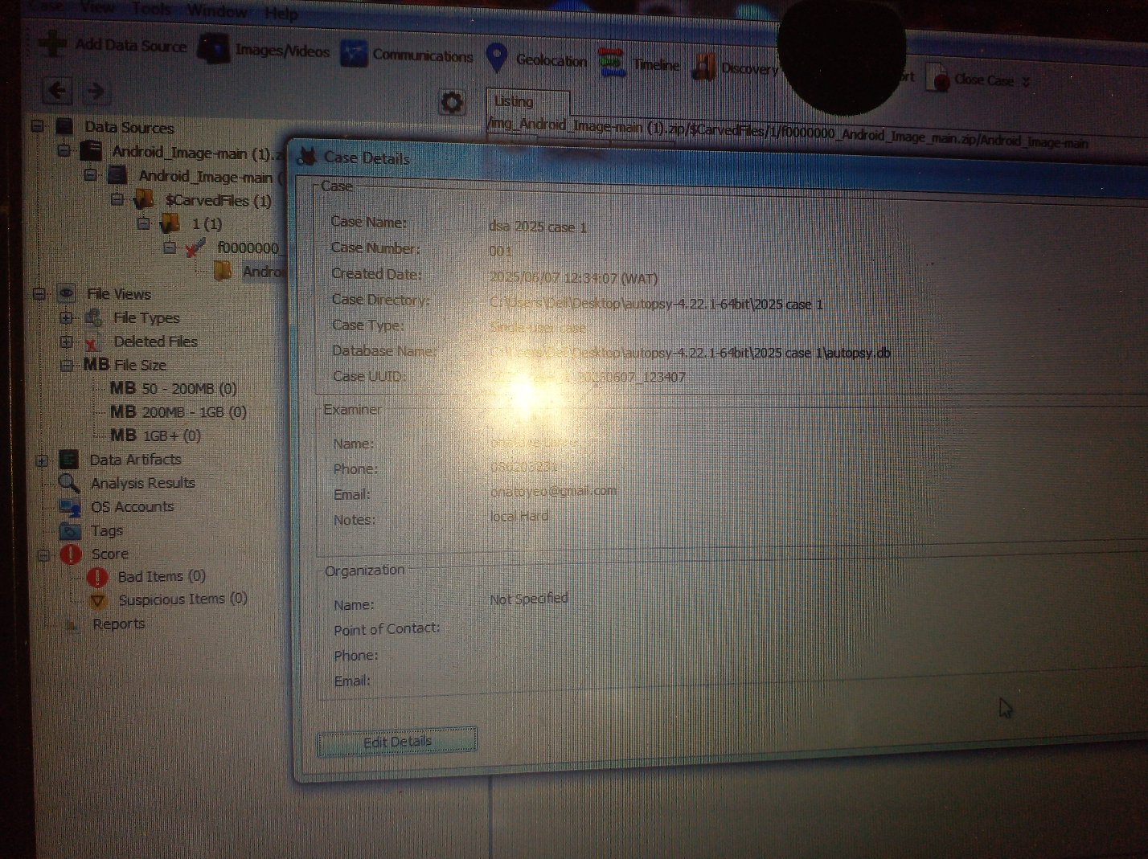

Autopsy Case file details

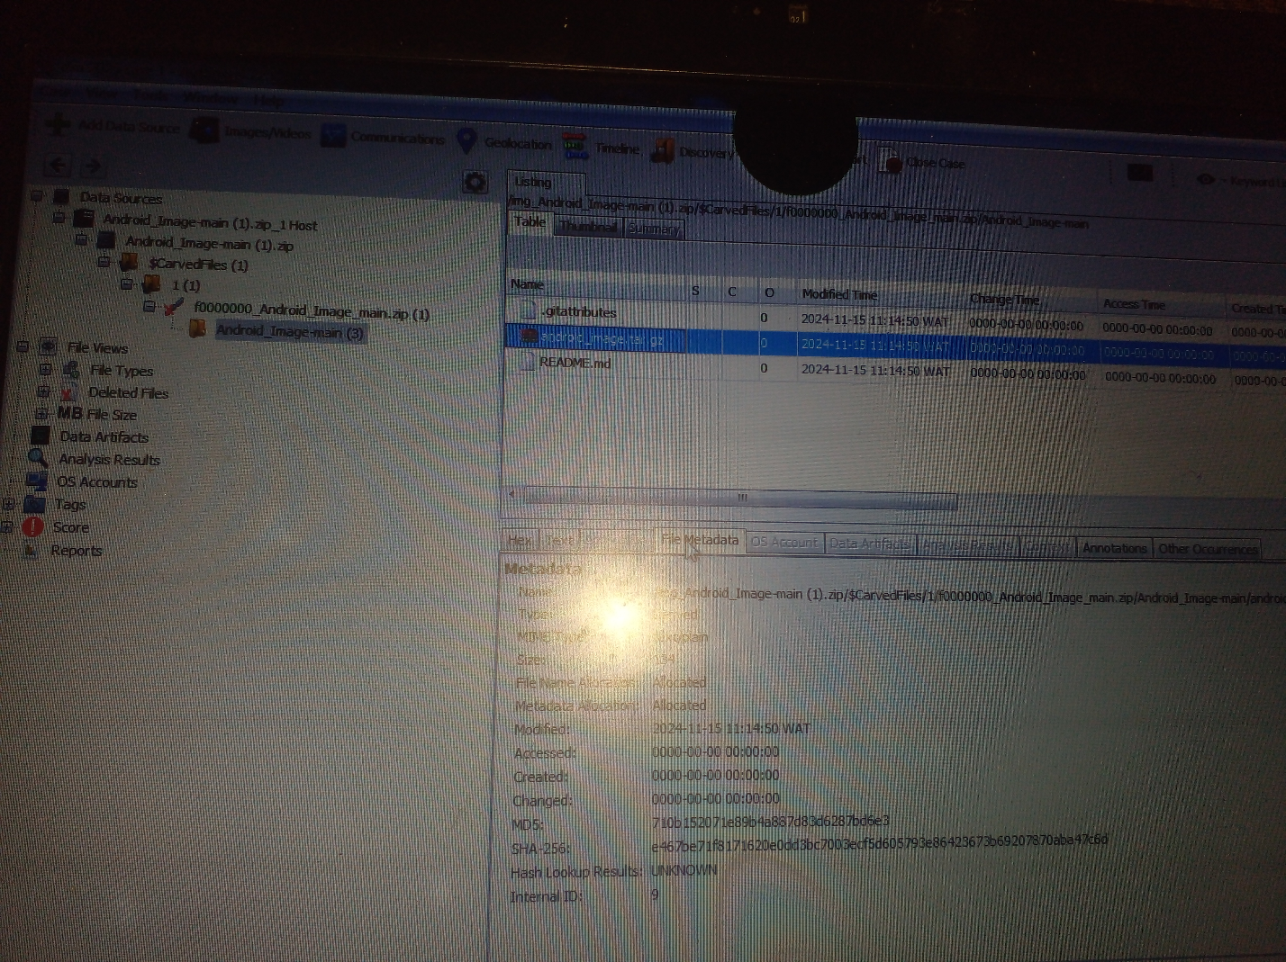

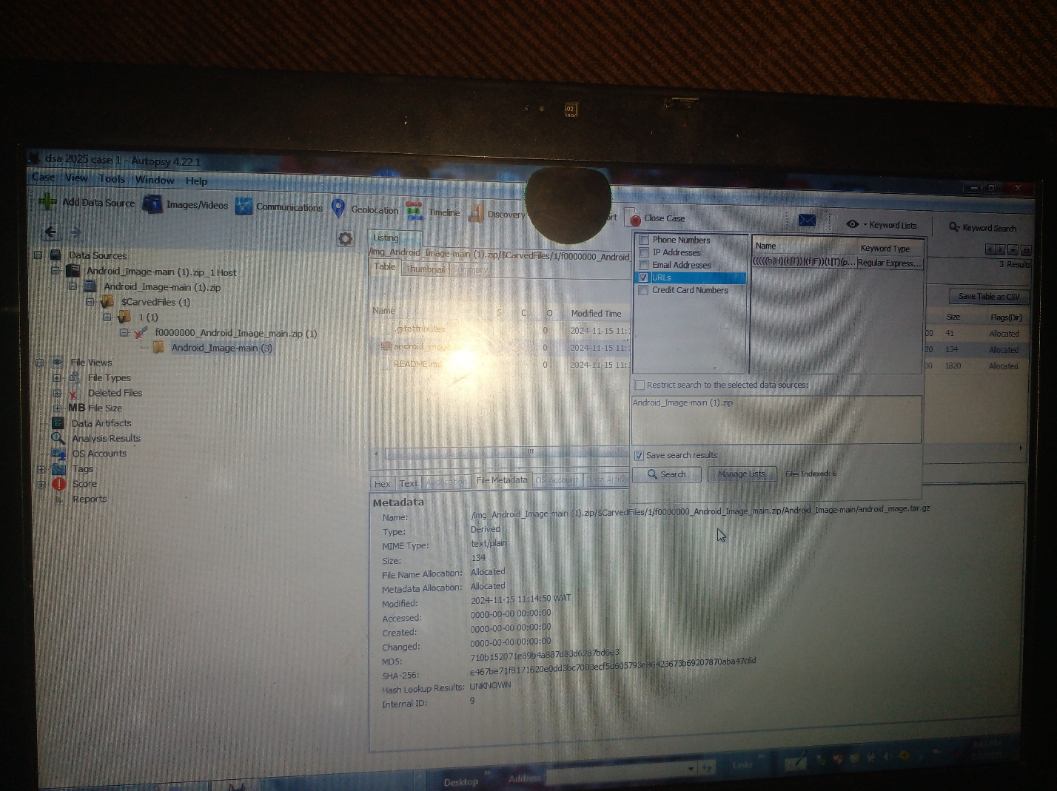

Metadata of forensic image

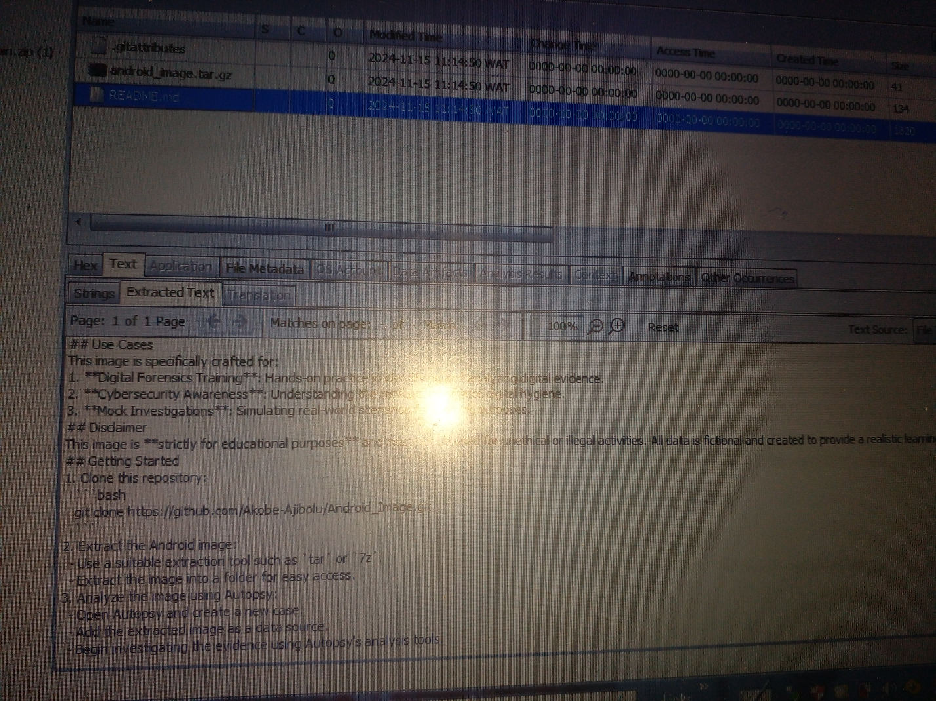

Extracted text of forensic image

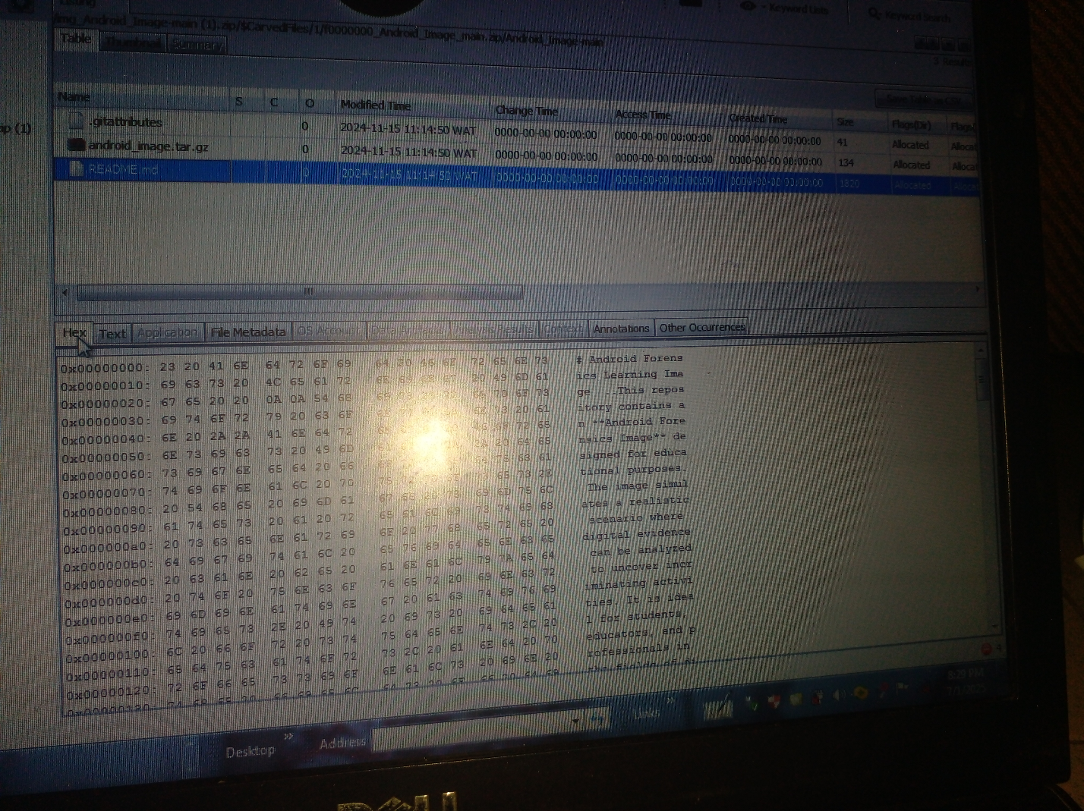

Fore

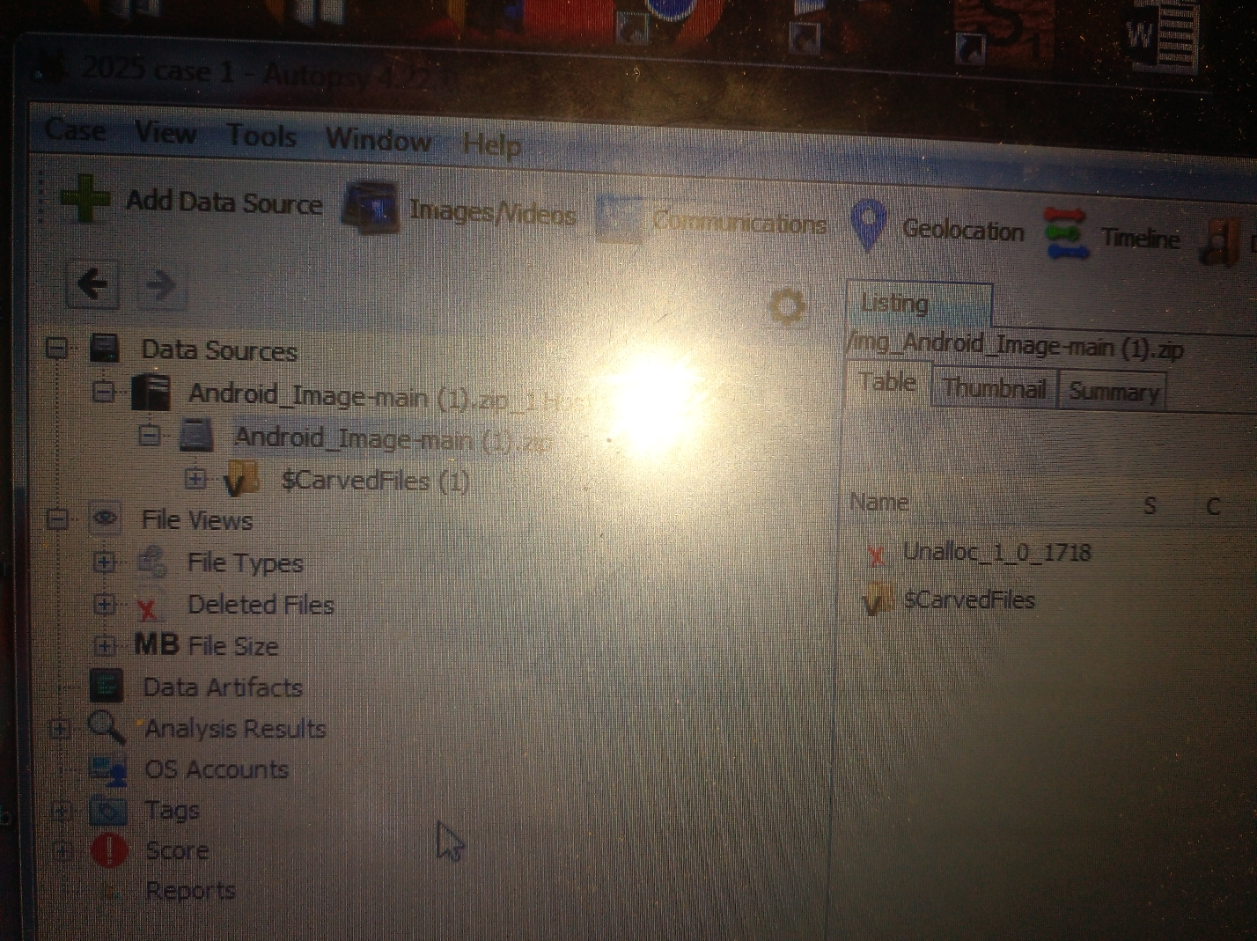

References: list of sources cited in the report